| Cardiovascular Impact of Viral Infections Prediction Using Machine Learning |

Suchismita Sarkar Simran Kumari Srishti Sawarna

1.Abstract

Cardiovascular disease (CVD) is one of the main disease in today's population world wide the main reason behind this hug break out of the disease is smoking, diabetes and high blood pressure its affect is not limited to the old generation its effects can be seen in younger generation which even worst the health issues.More over the research as shown that the viral infection may also impacted on the cardiovascular health. The viral infection has increase the chance of the heart disease which lead to poor health and increase the chance of disease that may damage the other organs in a body.The study with the use of Machine Learning with the help of the Random Forest Algorithm develop a predictive model for evaluation of Cardiovascular risk in the patient with the viral infections.The model aim to identify the risk factors with detects the risk of the disease at the early stage. Early detection may help the patient for there proper medication and avoid the change to contaminate with the viral infections which would lead to improving the outcome of the patient health.One of the major challenges while developing the model is the variability of the viral infections. Virus sometime evolve them self over the time which make it difficult to detect it more accurately by the model.The Random Forest algorithm is well suit because of its ability to handle large datasets with multiple independent and dependent variables.It constructs the multiple decision tree and merge them all for the output. The algorithm reduce the the risk of overfitting and improve the ability to generalize among the different patient population. Training the model with help of the real time data of various patient with various condition of the viral infection and its causing effect on the cardiovascular will get easy to detect the pattern and help to train the model more accurately.

2.Keywords

- Arrhythmia: An irregular heartbeat, which can be a result of cardiovascular disease.
- AUC-ROC : It is a metric used to evaluate a classification model's ability to distinguish between different classes, such as patients with and without cardiovascular complications.
- Inflammatory response : It is the body's immune reaction to infection or injury, often involving swelling, redness, and damage to tissues, which can affect the heart during viral infections.
- Viral myocarditis : It is the inflammation of the heart muscle caused by a viral infection, leading to potential heart dysfunction.
- Hyperparameter tuning : It is the process of adjusting the parameters of a machine learning model to improve its performance and accuracy.
- Therapeutic strategies : It refer to treatment plans and interventions designed to manage, alleviate, or cure medical conditions, including cardiovascular complications caused by viral infections.

3.Introduction
Cardiovascular diseases (CVDs) remain a leading global health concern, contributing significantly to mortality and morbidity. While established risk factors like smoking, diabetes, and hypertension are well-recognized, emerging research suggests a potential link between viral infections and CVD development. Current clinical evaluations, even comprehensive ones, often lack the sensitivity and specificity to accurately predict the long-term cardiovascular impact of viral infections. Therefore, this research aims to develop a predictive model for assessing CVD risk in individuals with a history of viral infection. Viral infections, with their ability to trigger a cascade of immune and inflammatory responses, have emerged as a potential culprit. The human body's defense mechanisms against viral invaders, while essential, can sometimes have unintended consequences. This chronic inflammation, even at a low level, can contribute to the development of atherosclerosis, the underlying pathology of many CVDs.Viral infections can directly or indirectly impact the myocardium, leading to a range of cardiovascular complications. Despite growing evidence linking viral infections to CVD, the clinical implications remain to be fully elucidated. Current clinical evaluations often lack the sensitivity and specificity to accurately predict the long-term cardiovascular impact of viral infections. Traditional diagnostic methods may not detect subtle changes in cardiac function or identify individuals at risk for developing future cardiovascular complications. This limitation underscores the need for more sophisticated tools to assess CVD risk in individuals with a history of viral infection. This research aims to develop a predictive model for assessing CVD risk in individuals with a history of viral infection. Leveraging machine learning techniques, specifically the Random Forest algorithm, we will analyze a large clinical dataset encompassing patient demographics, viral infection history, and relevant clinical indicators. The Random Forest algorithm is particularly well-suited for this task due to its ability to handle high-dimensional data, capture non-linear relationships, and reduce the risk of overfitting. The dataset will include patient demographics, viral infection history (type, duration, recurrences), and clinical indicators (blood pressure, cholesterol, inflammatory markers, cardiac function tests). The model will identify potential risk factors and generate personalized risk management recommendations. By identifying individuals at higher risk, this tool can facilitate earlier interventions, potentially preventing the development or progression of CVD associated with viral infections. Ultimately, this research seeks to improve patient outcomes by enabling proactive and targeted preventative and therapeutic strategies, thereby reducing the burden of virally-induced cardiovascular complications. This approach has the potential to revolutionize patient management by empowering clinicians with the insights needed to mitigate the long-term cardiovascular consequences of viral infections. This research aims to contribute to a deeper understanding of the complex relationship between viral infections and CVD, ultimately leading to improved prevention, diagnosis, and treatment strategies.

- Related Work

Cardiovascular Impact of Viral Infections was addressed in the literature using varius methods.
In [1] We have applied PCR to analyze myocardial biopsies for the presence of viral genomes in patients with myocarditis and dilated cardiomyopathy. The most commonly identified virus in children and adults is adenovirus and not, as formerly described, enteroviruses, long considered to be the principal cause of myocarditis. Adenovirus is therefore important in the etiology of myocarditis and deserves a revision of diagnostic and therapeutic approaches.
In [2] The role of human herpesvirus 6 (HHV-6) in pediatric myocarditis and dilated cardiomyopathy is still not clarified. HHV-6 has been shown to be associated with the heart among both healthy and diseased children; however, its exact contribution to pathology is under review. Active HHV-6 infection, specified by quantitative PCR or mRNA detection, plays a significant role, particularly in young children. Primary infection relates to phenomenon. Thus, the further studies should have been prospectively designed to develop definitive diagnostic criteria by comparison and relate their co-infection agents.
In [3] This is a case-control study examining the relationship between adenovirus (AdV) infection and atrial fibrillation (AF). Serum proteome profiling indicated an increased adenoviral signal in patients with AF. Follow-up analysis demonstrated a significantly higher prevalence of AdV-specific IgG antibodies (AdV-IgG) in patients with AF compared to controls. Additionally, obesity was related to increased AdV-IgG positivity in patients with AF. These results could indicate a potential role for AdV infection in the pathogenesis of AF, especially in obese individuals.
In [4] A 58-year-old male presented to the emergency department with an acute history of shortness of breath. An extensive work-up immediately yielded a diagnosis of pericardial effusion secondary to viral infection (coxsackievirus B) with tamponade effect of the heart. This information once again raises the awareness among healthcare professionals regarding the notorious course of coxsackievirus B infection and its potential fatal outcomes. It should drive them toward research—clinical and lab—to identify precisely the high-risk patient, and reconsider prevention strategies.
In [5] Influenza infection is associated with a higher risk of cardiovascular issues, such as myocardial infarction, heart failure, and mortality. Possible mechanisms include direct infection of the heart, dysfunction of the endothelium, and systemic inflammatory responses. Although the precise interactions among these factors are not fully understood, influenza infection notably increases the likelihood of acute cardiovascular events.
In [6] Effect of hepatitis B virus infection on right and left ventricular functions
A prior study involving 50 patients with HBV and 50 control subjects revealed signs of right ventricular systolic dysfunction in those with HBV. This was indicated by significantly reduced RV FAC, TAPSE, and RV myocardial systolic velocity, as well as larger RA and RV dimensions and heightened systolic pulmonary artery pressure when compared to the control group
In [7 ]A 35-year-old woman, who came with a febrile illness, the majority of which exhibited edema and rash which in the history was later diagnosed to be heart failure and anemia. The investigations further revealed that she had a B19V infection with GDF-15 cumulatively increased yet with hepcidin and erythroferrone levels remaining normal. This distinctive case presents proof for the first time about the capability of the virus in causing reversible heart failure and anemia alongside one individual with iron metabolism abnormalities, thus need for the differential diagnosis for heart failure with anemia to bear in mind B19V as a diagnosis for human disease as a case study.

In [8] Early research linked HIV-associated cardiovascular disease to antiretroviral therapy. However, emerging evidence emphasizes the role of HIV in itself, whereby viremia, immune dysregulation, and inflammation substantially contribute to the risk of CVD. Antiretroviral treatment significantly lessens that risk. Remaining hurdles arise from predicting and preventing CVD in this population. The further research focuses on improving the definition of the risk as well as determining diagnostic and treatment modalities.
In [9]Cardiovascular Disease and Covid-19: Systematic Review
Regarding literature on these areas, multiple studies have shown severe myocardial infarction, heart failure, myocarditis, and arrhythmias, acute cardiovascular complications with COVID-19. These complications often lead to Long COVID and eventually have possible microclotting consequences that continue to be the challenge of much more study for action as of now, particularly towards therapeutic intervention.
In [10]Before and During COVID- 19 Pandemic. Human metapneumovirus infection in the
Cardiac Pediatric Intensive Care Unit: A R etrospective Cohort Analysis
The study aimed to evaluate the effect of COVID-19-related infection control measures (social distancing and face mask) on the incidence of human metapneumovirus (hMPV) infections among children admitted with congenital heart diseases (CHD) in the pediatric cardiac ICU. A significant reduction in the incidence of hMPV infection was found during the post-pandemic period; the association was also linked to a longer admission period in the ICU and new pulmonary sequelae in children with CHD. It has been hypothesized that a better practice of cleanliness would have health utility in affected patients.

5.Methadology

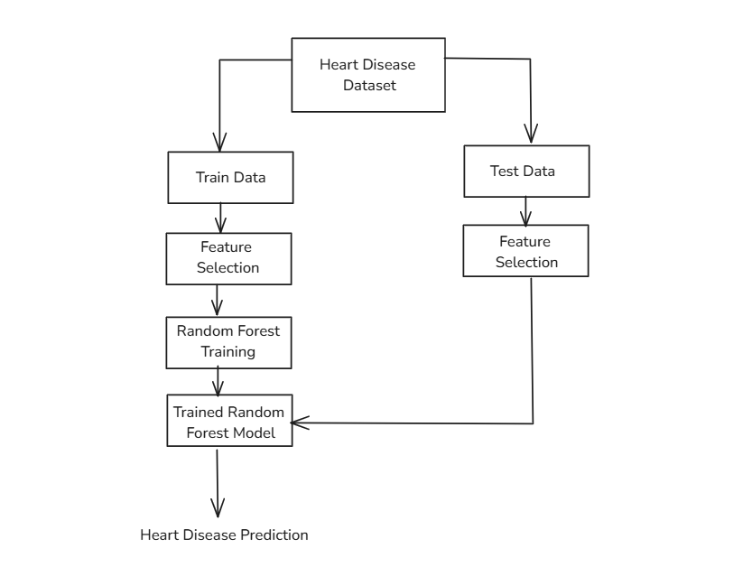

1.Data Collection & Preparation
Gathering Data Sources
In order to find out how viral infection affect human heart several things about patient must be researched . These mainly include basic aspects like age and gender, and also previous history on of having high blood pressure, blood sugar, cholesterol etc. Other data about virus is also required like virus type, intensity of affect and other harm caused during viral infection

Data Extraction:
Proper extraction of data is required to keep a track on health markers such as ECG report, Bkood reports etc. After this certain question may arise like what were the aftereffects on heart. This collection of data will give us useful information.

S.No | Observation | Description | Values
1 | Age | Patient's age | Int64
2 | Sex | Sex of the patient | Int64
3 | Cp | Chest pain type | Int64
4 | Trestbps | Resting blood pressure (in mm Hg) | Int64
5 | Chol | Cholesterol in mg/dl fetched via BMI sensor | Int64
6 | Fbs | Fasting blood sugar > 120 mg/dl (1 = true; 0 = false) | Int64
7 | Restecg | Resting electro-cardiographic results | Int64
8 | Thalach | Maximum heart rate achieved | Int64
9 | Exang | Exercise induced angina (1 = yes; 0 = no) | Int64
10 | Oldpeak | Exercise induced ST -segment depression relativefloat64to restfulness | Int64
11 | Slope | The slope of the peak exercise ST segment | Int64
12 | Ca | Number of major vessels (0-3) colored by flourosopy | Int64
13 | Thal | Thalium Stress Test result (1-3) | Int64
14 | Target | 0 = less chance of heart attack, 1= more chance ofint64heart attack | Int64

Data Cleaning & Preprocessing
It is necessary to cleanse data before further processing. Data that is not cleansed properly is like a incomplete puzzle. Data cleansing is referred to the removal of corrupted, duplicate and incorrect files from data, If data is incorrect then it is not reliable to perform algorithms on it. Although sometimes it may appear correct but we can identify the error while processing it, Data cleansing basically removes the data that is not required in the dataset.On the other hand after data cleansing comes the data data preprocessing part where data is data is standardized and normalized. Here data is split-ed into training and testing.
2.Model Development
Choosing Machine Learning Algorithm
It is necessary to choose the best algorithm for our model deployment part in order to get accurate and precised outcomes. For our study we have used Rando Forest Classifier algorithm. We have also compared it with other algorithms such as Logistic Regression, Support Vector Machine, Naive Bayes and Decision Tree. We will test every algorithm and derive which algorithm suits best for our prediction model. We need a model that correctly identifies the most contributing factors in cardiovascular risk due to viral infections.Below are the definitions of the algorithms used.
Random Forest: It is an learning approach that creates multiple decision trees during training time and the output results are the mean/mode prediction of the individual trees. It's insensitive to overfitting and does well with high dimensionality.
Logistic Regression: It is is a linear model used in binary classification problems. It gives the probability of a class, defined through the use of sigmoid function.
SVM (Support Vector Machine): Hera a optimal hyperplane is used that maximally separates data points of different classes that are found. It can even handle non-linear data using kernel tricks
Decision Tree: It consists of tree-like structure with each internal node representing a feature, each branch representing a decision rule, and each leaf node representing an outcome. They are easy to interpret but are prone to overfitting
Naive Bayes: It is a probabilistic classifier based on Bayes' theorem. Here, features are assumed to be independent of each other, making calculations much simpler. It is used in text classifications and spam filtering.

Model Training
Here we begin with training the model of the Random Forest till its perfect. The model accepted the prepared training data, as it practiced passing correlations coming from the fed features (patient characteristics, details of viral infection, etc.) to the target variable (cardiovascular impact). It used hyper parameter tuning for performing fine-tuning in conjunction with decision convergence. A grid search combined with cross-validation was performed in searching systematically different parameter settings and combinations such as searching the number of decision trees within the forest or the maximum depth of each tree for systematically evaluating parameter settings to identify which produce the best and most robust predictions.
Model Evaluation:
In testing the performance of the Random Forest model, we have held in-depth evaluation of model predictions on an independent test dataset. We used extensive ranges of metrics to measure the accuracy. Precision is defined as the ratio of true positive predictions among all reached positive predictions; it was imperative to lower the false alarms and break-through procedures. Recall is the counterpoint that determines the ability of the model to recognize true-case infections and to ensure that no individuals at high risk are left behind among the ranks. Then the F1 score was precisely established to aid precision and recall for a single metric that shows predictive performance and combines its relative merits. Finally, we compared the performance of the model relative to AUC-ROC metrics that would score its discrimination among those who may have developed versus those without any cardiovascular complications as a way to generally determine diagnostic performance.
Precision is calculated as, P = TP/(TP+FP)
Recall is calculated as, R = TP/(TP+FN)
F1-Score is calculated as, F1= 2*(P*R)/P+R
Accuracy = (True Positive+True Negative)/Total Sample

6. Results and Interpretations
Now the effectiveness of each and every model was tested comprehensively by assessing its predictive accuracy along with F1Score and Recall regarding cardiovascular complications post-viral infections. Here is the data of all the algorithms.
Method | Recall | F1-Score | Accuracy
Random Forest | 0.844 | 0.871 | 0.869
Logistic Regression | 0.844 | 0.857 | 0.852
Naive Bias | 0.844 | 0.871 | 0.869
Support Vector Model | 0.844 | 0.871 | 0.869
Descision Tree Classifier | 0.656 | 0.737 | 0.754

Graphical Representation
Confusion Matrix: A confusion matrix basically summarizes the performance of a classification model, showing the counts of true positive, true negative, false positive, and false negative predictions.
Actual class | Predicted Value
 |  | P | N
 | P | True Positive (TP) | True Positive (TP)
 | N | False Negative (FN) | False Negative (FN)

ROC Curve: An ROC curve stands for Receiver Operating Characteristic is used for visualizing the trade-off between true positive rate and false positive rate at different classification thresholds, thus helping in evaluation of a model's ability to distinguish between different classes. \

Method | Confusion Matrix | ROC-Curve
Random Forest | 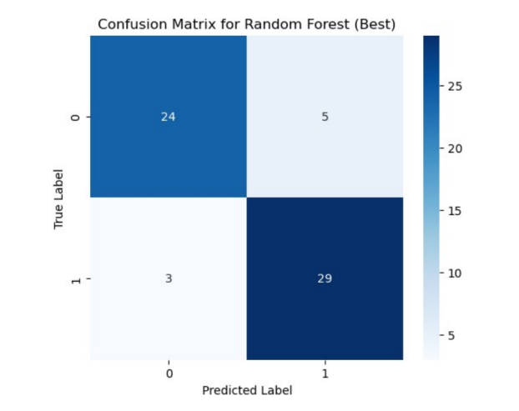 | 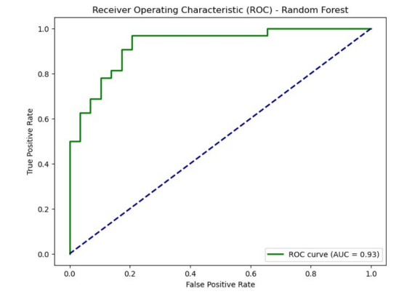
Logistic Regression | 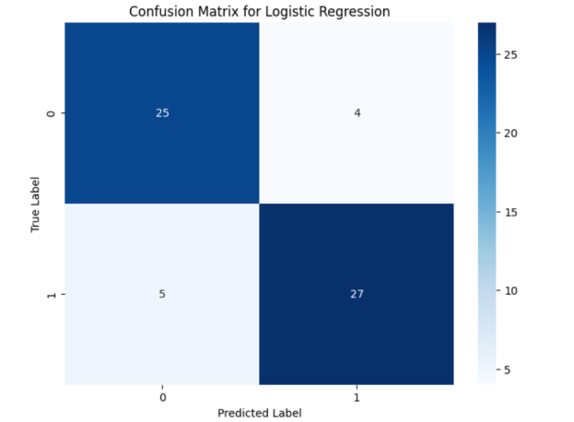 | 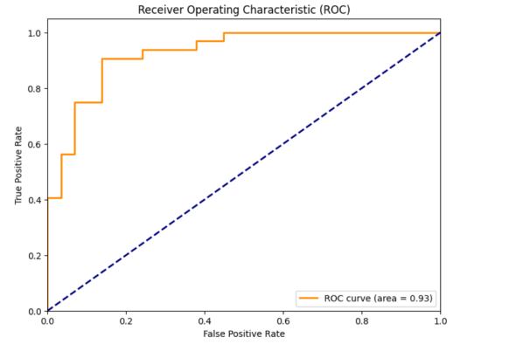
Naive Bias | 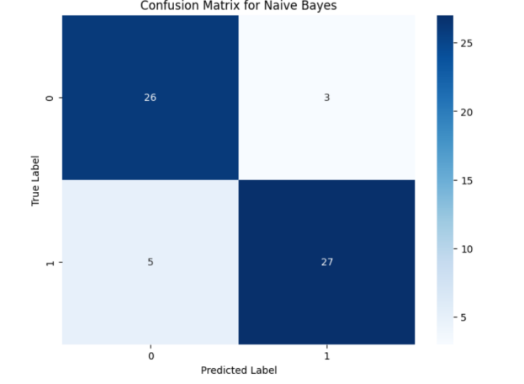 | 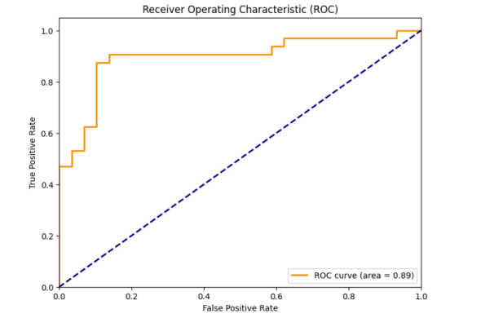

Support Vector Model | 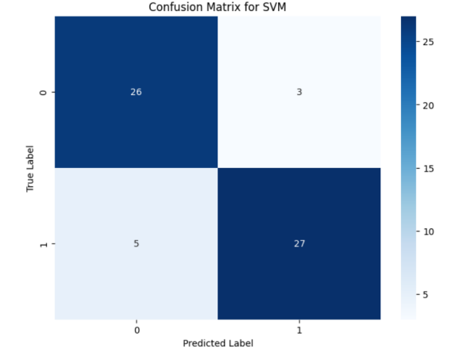 | 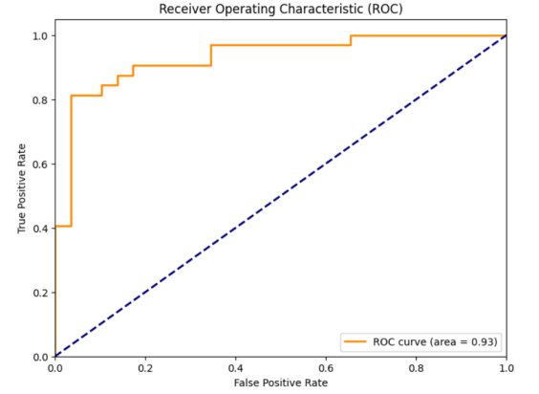
Descision Tree Classifier | 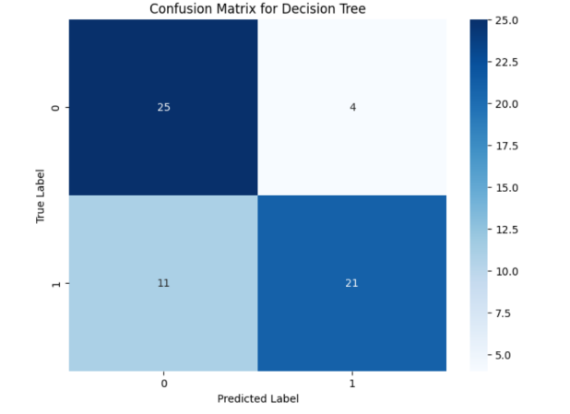 | 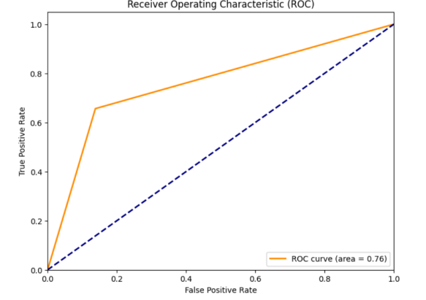

Comparison Between the above Machine Learning Model.
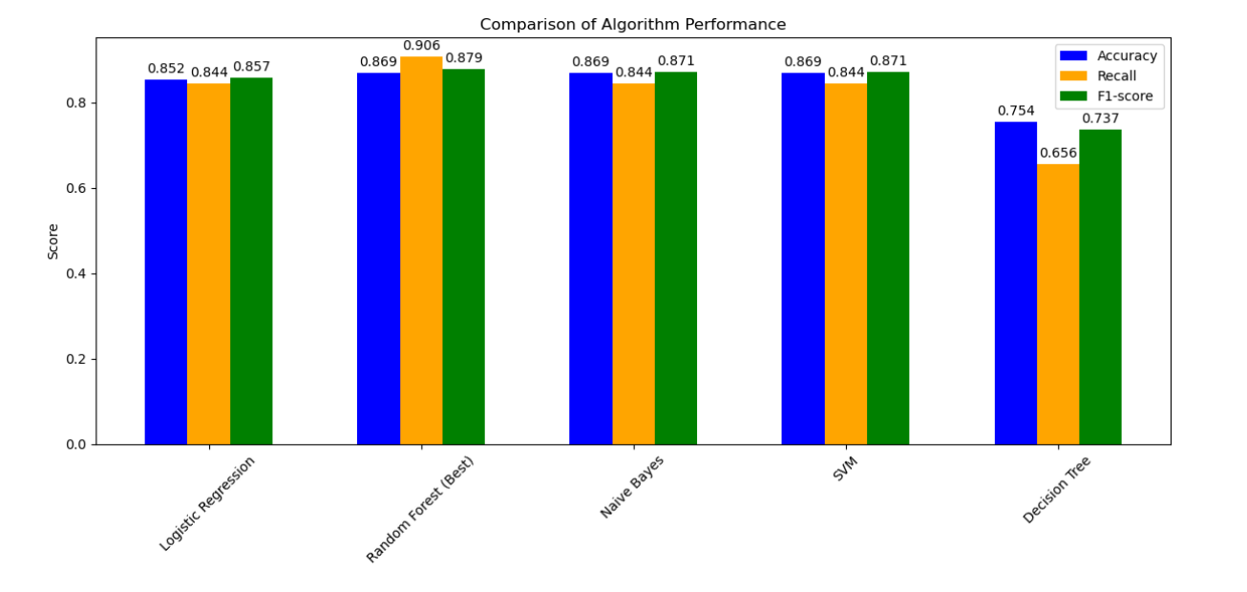
The above chart compares various machine learning algorithms with Random Forest, making it very clear how well Random Forest stands out above the rest: It does so for both accuracy, recall, and their sum in F1-score. All of these together make this the perfect result for our study into predicting risk from heart disease due to viral infections. We need a model that is generally accurate but good at picking the ones who really have the condition-thereby increasing recall without going too wild on false positives. That is precisely what the Random Forest brings, which makes it very useful for heart health applications. In addition, its handling of complex data is really important, since the relationship between viruses, the immune system, and the heart is really complex. It is kind of like how Random Forest could see everything and then some; thus, it's a great algorithm for complex prediction tasks.

7.References
- Bowles, N. E., Ni, J., Kearney, D. L., Pauschinger, M., Schultheiss, H.-P., McCarthy, R., Hare, J., Bricker, J. T., Bowles, K. R., & Towbin, J. A. (2003). Detection of viruses in myocardial tissues by polymerase chain reaction: Evidence of adenovirus as a common cause of myocarditis in children and adults.Journal of the American College of Cardiology, 42(3), 466–472.
[2]Reddy S, Eliassen E, Krueger GR, Das BB.Human herpesvirus 6-induced inflammatory cardiomyopathy in immunocompetent children.Ann Pediatr Cardiol. 2017;10(3):259-268. doi:10.4103/apc.APC_54_17.
[3] N. G. Gumanova, P. D. Zlobina, N. L. Bogdanova, H. A. Brutyan, E. N. Kalemberg, V. A. Metelskaya, K. V. Davtyan, and O. M. Drapkina, “Associations of adenovirus-reactive immunoglobulins with atrial fibrillation and body mass index,” Frontiers in Cardiovascular Medicine, vol. 10, p. 1190051, May 2023.
[4] F. Kandah, P. Dhruva, J. Ruiz, A. Martinez, and W. Kogler, “Coxsackievirus B infection presenting as a hemorrhagic pericardial effusion causing tamponade,” J. Geriatr. Cardiol., vol. 17, pp. 642–644, Oct. 2020.
[5] K. G. Skaarup, D. Modin, L. Nielsen, J. U. S. Jensen, and T. Biering-Sørensen, “Influenza and cardiovascular disease pathophysiology: Strings attached,” Eur. Heart J. Suppl., vol. 25, no. Supplement A, pp. A5–A11, 2023.
[6] M. Demir and C. Demir, "Effect of hepatitis B virus infection on right and left ventricular functions," Medical Science Monitor, vol. 18, no. 9, pp. CR587-CR591, Sep. 2012. DOI: 10.12659/MSM.883356.
[7] Y. Nakamura et al., "The Impact of Human Parvovirus B19 Infection on Heart Failure and Anemia with Reference to Iron Metabolism Markers in an Adult Woman," Internal Medicine, vol. 57, no. 4, pp. 403-407, 2018, doi: 10.2169/internalmedicine.8809-17.
[8] M. J. Feinstein, "HIV and Cardiovascular Disease: From Insights to Interventions," Topics in Antiviral Medicine, vol. 29, no. 4, pp. 407-411, Oct./Nov. 2021.
[9] Y. Nakamura et al., "The Impact of Human Parvovirus B19 Infection on Heart Failure and Anemia with Reference to Iron Metabolism Markers in an Adult Woman," Internal Medicine, vol. 57, no. 4, pp. 403-407, 2018, doi: 10.2169/internalmedicine.8809-17.
[10] N. Leister et al., "Human metapneumovirus infection in the cardiac paediatric ICU before and during COVID-19 pandemic: a retrospective cohort analysis," Cardiology in the Young, vol. 2022, pp. 1-6, 2022.

8.Conclusion
In conclusion, this research analyzes about the possible connection between viral infections and cardiovascular disease by developing a predictive model determining heart disease risk in individuals with a history of viral infection. We take into consideration the performance of several machine learning algorithms, including Random Forest, Logistic Regression, Naive Bayes, SVM, and Decision Tree, using a dataset of relevant patient information to detect the possibility of patients with viral infection history leading to some or the other cardiovascular diseases. Our analysis and prediction of the model demonstrates that the performance of the Random Forest algorithm in this specific context is the best fit. As per the provided data, the bar graph shows that Random Forest has achieved the highest scores across accuracy, recall, and F1-score among all five algorithms as referred earlier, indicating its effectiveness in capturing the complex relationships between viral infections and the cardiovascular disease it results in. This balanced performance is crucial for our objective, ensuring both accurate identification of at-risk individuals and minimization of false positives or false negatives(where people fail to know about their conditions).While other algorithms, such as Logistic Regression and Naive Bayes, also demonstrated reasonable performance but Random Forest's overall performance makes it a very promising tool for this application. There still exists a slight contrast in the reference text, which favored SVM for general heart disease prediction but the difference in recall highlights the importance of using the chosen algorithm for this specific research question and dataset. In our study, we focus mainly on the post-viral impact on cardiovascular health, Random Forest proved to be more proficient at determining the relevant patterns of this case.This research provides a strong foundation for future purposes. Although Random Forest is promising,still further refinement is possible. Expanding the dataset to include more diverse patient populations and a wider range of viral infections could further enhance the model's prediction capacity and accuracy. Optimizing the Random Forest model itself, through hyperparameter tuning or feature selection, may also lead to improved predictive accuracy. Ultimately, our goal is to equip clinicians with a practical tool for proactive identification and management of long-term cardiovascular risks associated with viral infections. We believe that machine learning, particularly with algorithms like Random Forest, has significant potential to advance our understanding and treatment of viral-induced heart conditions, ultimately improving patient outcomes.

